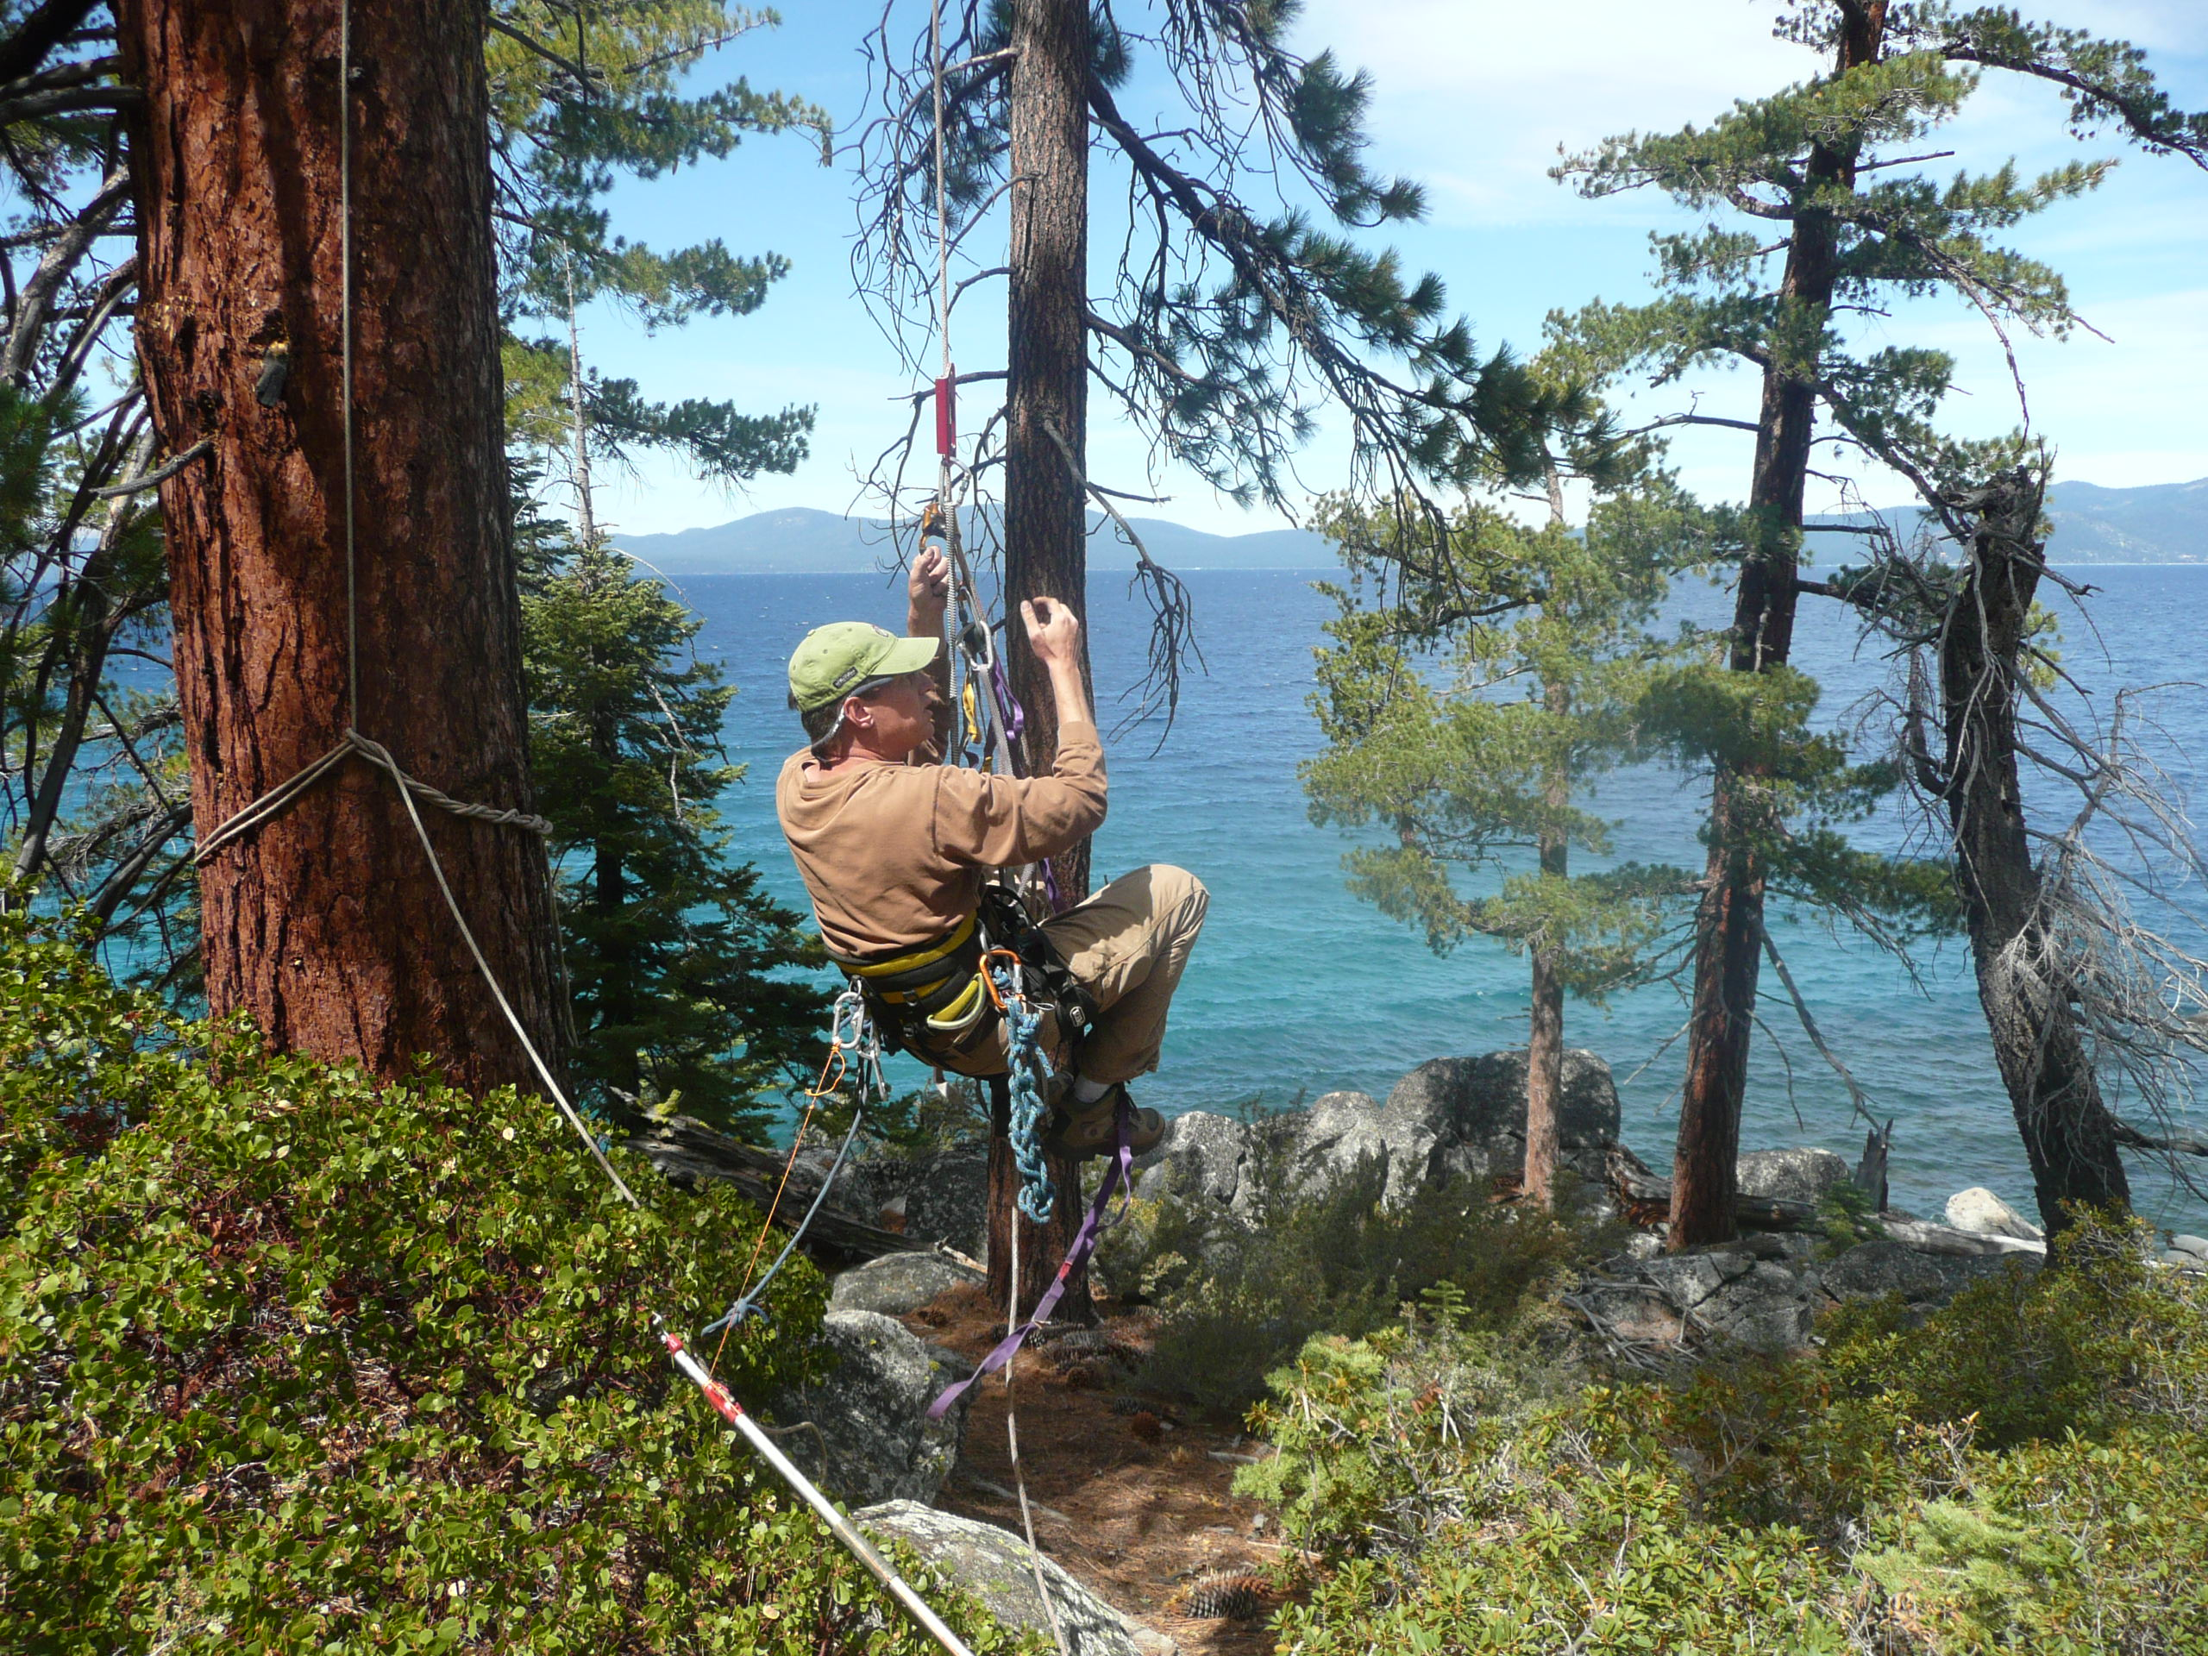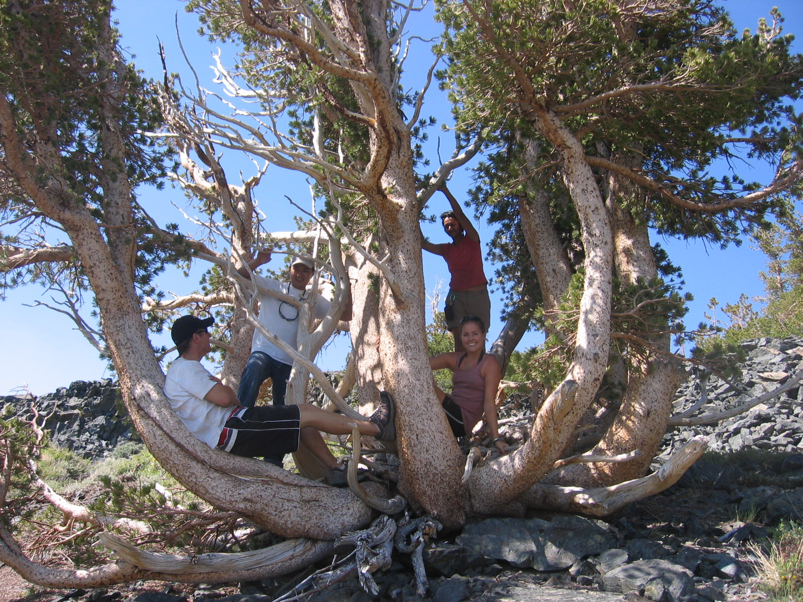

### Meet at Van Sickle State Park, Nevada parking lot

A society grows great

when people plant trees

whose shade

they know

they shall never

enjoy.

-Greek Proverb

6/30, 7/20, 7/27, 8/4

10am-noon

**Sign up at Explore Tahoe  
 call Maria Mircheva at 650-814-9565**

**or e-mail Maria@sugarpinefoundation.org**

# Hike 4 miles at Van Sickle State Parks with an expert naturalist. Learn about Sugar Pines and forest stewardship. Bring the family and help Bring Back the Sugar Pines!

## Come see how we climb 100ft pines to harvest their cones!

**with the Sugar Pine Foundation**

**Guided Nature Hikes**

**Hang out in the pines**

**Come to the forest**

**Sweet Summer Hikes**