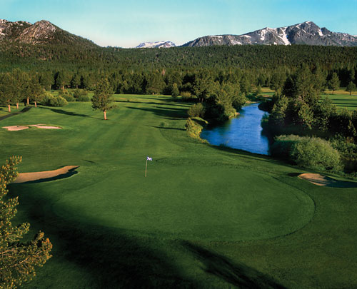



**1st annual**

**tahoe turning point**

**annual charity golf tournament**

**BE A TOURNAMENT SPONSOR**

**ACE LEVEL: $3,500**

Includes Company Logo on Tee-prize Pro V I Golf Balls, 2-Foursomes, on course and other recognition, and benefits.

**BIRDIE LEVEL: $1,500**

Includes 2 Foursomes, on-course and other recognition, and benefits.

**PAR LEVEL $900**

Includes 1-Foursome, on-course recognition and benefits.

**BOGIE LEVEL: $500**

Includes: On-course and other recognition. No Players.

Please contact Tahoe Turning Point:

Rich Barna, Executive Director

530-541-4594 or 530-545-0891

[Rich.Barna@TahoeTurningPoint.org](mailto:Rich.Barna@TahoeTurningPoint.org)

**TOURNAMENT SCHEDULE**

(Format: Scramble)

8:30am Registration, Breakfast Buffet, Range Balls

10:00am Shotgun Start

3:00pm Post tournament BBQ, Awards, Silent Auction

**Thursday, September 17, 2015**

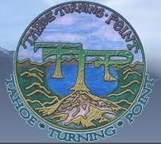

**TAHOE TURNING PONT**

Tahoe Turning Point, a 501c3 Non-Profit Organization, was founded in 1980 to provide programs and services in our communities. Since our inception, our organization has continued to expand in order to meet the needs of our clients. We currently provide the following programs and services:

* Five Group Homes for Youth ages 13-18
* Counseling services for youth & adults
* Transitional Housing Programs for young adults ages 18-26





**G.B.**

General Engineering Contractor, Inc.